Program 1: Create a New Process and Display Process ID & Parent Process ID
#include <stdio.h>
#include <unistd.h>
int main()
{
printf("Process ID : %d\n", getpid());
printf("Parent Process ID : %d\n", getppid());
return 0;
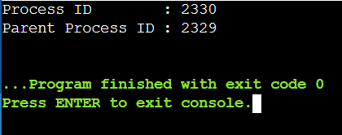
}

Program 2: Copy the Contents of One File to Another
#include <stdio.h>
#include <stdlib.h>
int main()
{
FILE *source, *destination;
char sourceFile[100], destinationFile[100];
char ch;
printf("Enter the source file name: ");
scanf("%s", sourceFile);
printf("Enter the destination file name: ");
scanf("%s", destinationFile);
source = fopen(sourceFile, "r");
if (source == NULL)
{
printf("Error: Unable to open source file.\n");
return 1;
}
destination = fopen(destinationFile, "w");
if (destination == NULL)
{
printf("Error: Unable to create destination file.\n");
fclose(source);
return 1;
}
while ((ch = fgetc(source)) != EOF)
{
fputc(ch, destination);
}
printf("\nFile copied successfully.\n");
fclose(source);
fclose(destination);
return 0;
}
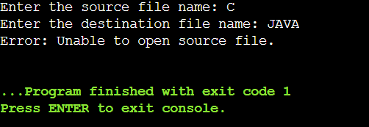

Program 3: First Come First Served (FCFS) Scheduling
#include <stdio.h>
int main()
{
int n, i;
int burstTime[20];
int waitingTime[20];
int turnaroundTime[20];
float avgWT = 0, avgTAT = 0;

printf("Enter the number of processes: ");
scanf("%d", &n);
printf("\nEnter Burst Time for each process:\n");
for (i = 0; i < n; i++)
{
printf("P%d: ", i + 1);
scanf("%d", &burstTime[i]);
}
waitingTime[0] = 0;
for (i = 1; i < n; i++)
{
waitingTime[i] = waitingTime[i - 1] + burstTime[i - 1];
}
printf("\nProcess\tBT\tWT\tTAT\n");
for (i = 0; i < n; i++)
{
turnaroundTime[i] = burstTime[i] + waitingTime[i];
avgWT += waitingTime[i];
avgTAT += turnaroundTime[i];
printf("P%d\t%d\t%d\t%d\n",
i + 1,
burstTime[i],
waitingTime[i],
turnaroundTime[i]);
}
avgWT /= n;
avgTAT /= n;
printf("\nAverage Waiting Time = %.2f", avgWT);
printf("\nAverage Turnaround Time = %.2f\n", avgTAT);

return 0;
}
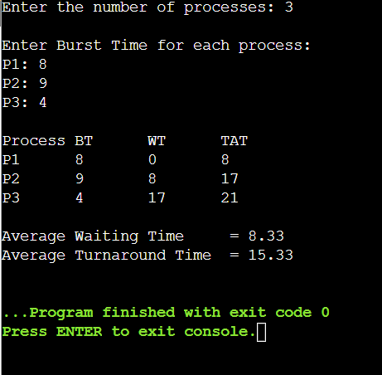

Program 4: Shortest Job First (SJF) Scheduling (Non-Preemptive)
#include <stdio.h>
int main()
{
int n, i, j;
int burstTime[20], process[20];
int waitingTime[20], turnAroundTime[20];
int temp;
float avgWT = 0, avgTAT = 0;
printf("Enter the number of processes: ");
scanf("%d", &n);
printf("\nEnter Burst Time for each process:\n");
for (i = 0; i < n; i++)
{
process[i] = i + 1;
printf("P%d: ", process[i]);
scanf("%d", &burstTime[i]);
}
/* Sort processes according to Burst Time */
for (i = 0; i < n - 1; i++)
{
for (j = i + 1; j < n; j++)
{
if (burstTime[i] > burstTime[j])
{
temp = burstTime[i];
burstTime[i] = burstTime[j];
burstTime[j] = temp;
temp = process[i];
process[i] = process[j];
process[j] = temp;
}
}
}
waitingTime[0] = 0;
for (i = 1; i < n; i++)
{
waitingTime[i] = waitingTime[i - 1] + burstTime[i - 1];
}
printf("\nProcess\tBurst Time\tWaiting Time\tTurnaround Time\n");
for (i = 0; i < n; i++)
{
turnAroundTime[i] = burstTime[i] + waitingTime[i];
avgWT += waitingTime[i];
avgTAT += turnAroundTime[i];
printf("P%d\t%d\t\t%d\t\t%d\n",
process[i],
burstTime[i],
waitingTime[i],
turnAroundTime[i]);
}
avgWT /= n;
avgTAT /= n;
printf("\nAverage Waiting Time = %.2f", avgWT);
printf("\nAverage Turnaround Time = %.2f\n", avgTAT);
return 0;
}
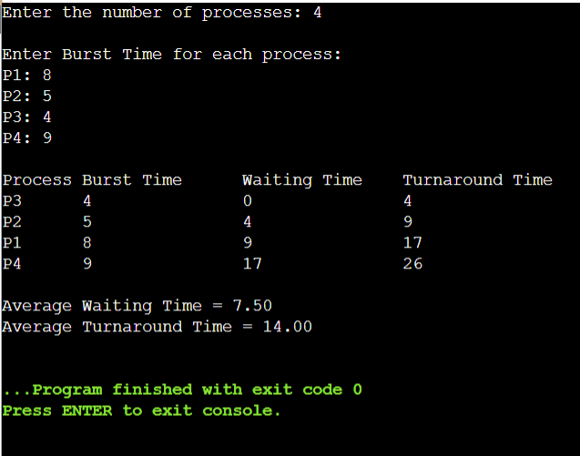

Program 5: Priority Scheduling (Non-Preemptive)
#include <stdio.h>
int main()
{
int n, i, j;
int process[20], burstTime[20], priority[20];
int waitingTime[20], turnAroundTime[20];
int temp;
float avgWT = 0, avgTAT = 0;

printf("Enter the number of processes: ");
scanf("%d", &n);
printf("\nEnter Burst Time and Priority for each process:\n");
for (i = 0; i < n; i++)
{
process[i] = i + 1;
printf("\nProcess P%d\n", process[i]);
printf("Burst Time : ");
scanf("%d", &burstTime[i]);
printf("Priority (Smaller number = Higher priority): ");
scanf("%d", &priority[i]);
}
/* Sort according to Priority */
for (i = 0; i < n - 1; i++)
{
for (j = i + 1; j < n; j++)
{
if (priority[i] > priority[j])
{
temp = priority[i];
priority[i] = priority[j];
priority[j] = temp;
temp = burstTime[i];
burstTime[i] = burstTime[j];
burstTime[j] = temp;
temp = process[i];
process[i] = process[j];
process[j] = temp;
}
}
}
waitingTime[0] = 0;
for (i = 1; i < n; i++)
{
waitingTime[i] = waitingTime[i - 1] + burstTime[i - 1];
}
printf("\n----------------------------------------------------------\n");
printf("Process\tPriority\tBurst Time\tWaiting Time\tTurnaround Time\n");
printf("----------------------------------------------------------\n");
for (i = 0; i < n; i++)
{
turnAroundTime[i] = burstTime[i] + waitingTime[i];
avgWT += waitingTime[i];
avgTAT += turnAroundTime[i];
printf("P%d\t%d\t\t%d\t\t%d\t\t%d\n",
process[i],
priority[i],
burstTime[i],
waitingTime[i],
turnAroundTime[i]);
}
avgWT /= n;
avgTAT /= n;
printf("\nAverage Waiting Time : %.2f", avgWT);
printf("\nAverage Turnaround Time : %.2f\n", avgTAT);
return 0;
}
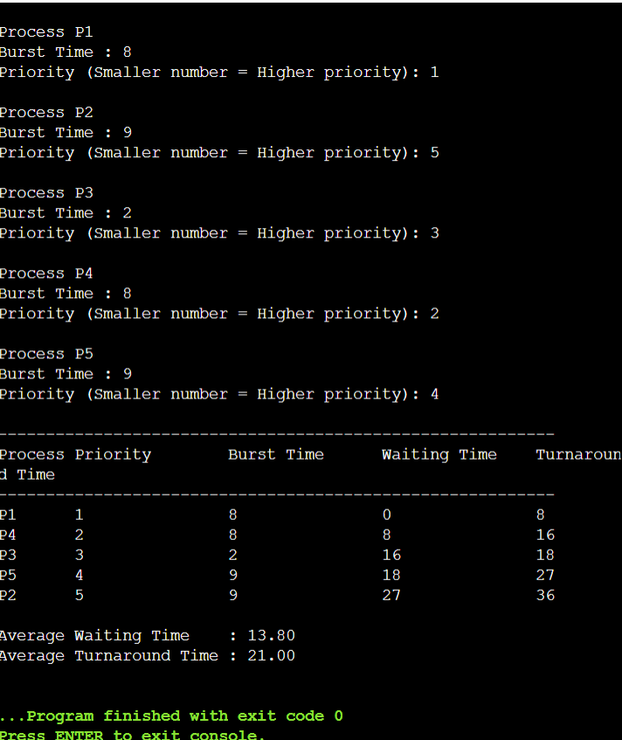

Program 6: Preemptive Priority Scheduling
#include <stdio.h>
int main()
{
int n, i, time = 0, completed = 0;
int bt[20], at[20], pr[20], rt[20];
int wt[20], tat[20];
int highestPriority, currentProcess;
int isCompleted[20] = {0};

float avgWT = 0, avgTAT = 0;
printf("Enter the number of processes: ");
scanf("%d", &n);
printf("\nEnter Arrival Time, Burst Time and Priority\n");
printf("(Smaller priority number = Higher Priority)\n\n");
for (i = 0; i < n; i++)
{
printf("Process P%d\n", i + 1);
printf("Arrival Time : ");
scanf("%d", &at[i]);
printf("Burst Time : ");
scanf("%d", &bt[i]);
printf("Priority : ");
scanf("%d", &pr[i]);
rt[i] = bt[i];
printf("\n");
}
while (completed != n)
{
highestPriority = 9999;
currentProcess = -1;
for (i = 0; i < n; i++)
{
if (at[i] <= time && !isCompleted[i] && pr[i] < highestPriority)
{
highestPriority = pr[i];
currentProcess = i;
}
}
if (currentProcess == -1)
{
time++;
continue;
}
rt[currentProcess]--;
time++;
if (rt[currentProcess] == 0)
{
isCompleted[currentProcess] = 1;
completed++;
tat[currentProcess] = time - at[currentProcess];
wt[currentProcess] = tat[currentProcess] - bt[currentProcess];
if (wt[currentProcess] < 0)
wt[currentProcess] = 0;
avgWT += wt[currentProcess];
avgTAT += tat[currentProcess];
}
}
printf("\n---------------------------------------------------------------\n");
printf("Process\tAT\tBT\tPriority\tWT\tTAT\n");
printf("---------------------------------------------------------------\n");
for (i = 0; i < n; i++)
{
printf("P%d\t%d\t%d\t%d\t\t%d\t%d\n",
i + 1,
at[i],
bt[i],
pr[i],
wt[i],
tat[i]);
}

avgWT /= n;
avgTAT /= n;
printf("\nAverage Waiting Time = %.2f", avgWT);
printf("\nAverage Turnaround Time = %.2f\n", avgTAT);
return 0;
}
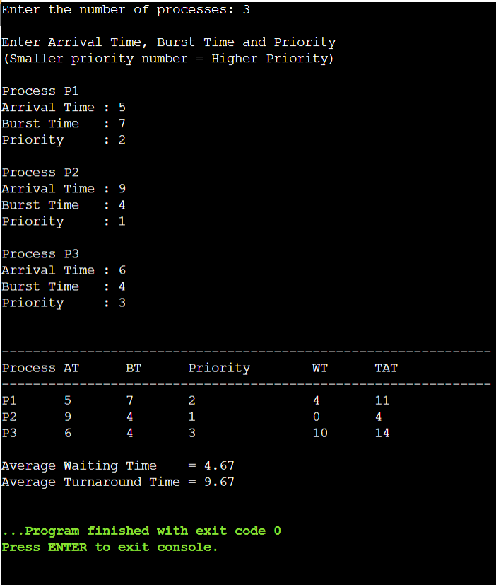

Program 7: Non-Preemptive Shortest Job First (SJF) Scheduling
#include <stdio.h>

int main()
{
int n, i, j;
int process[20], arrivalTime[20], burstTime[20];
int waitingTime[20], turnAroundTime[20];
int completed[20] = {0};
int currentTime = 0, completedCount = 0;
int shortest, minBurst;
float avgWT = 0, avgTAT = 0;
printf("Enter the number of processes: ");
scanf("%d", &n);
printf("\nEnter Arrival Time and Burst Time:\n");
for (i = 0; i < n; i++)
{
process[i] = i + 1;
printf("\nProcess P%d\n", process[i]);
printf("Arrival Time : ");
scanf("%d", &arrivalTime[i]);
printf("Burst Time : ");
scanf("%d", &burstTime[i]);
}
while (completedCount < n)
{
shortest = -1;
minBurst = 9999;
for (i = 0; i < n; i++)
{
if (!completed[i] &&
arrivalTime[i] <= currentTime &&
burstTime[i] < minBurst)
{
minBurst = burstTime[i];
shortest = i;
}
}
if (shortest == -1)
{
currentTime++;
continue;
}
waitingTime[shortest] = currentTime - arrivalTime[shortest];
if (waitingTime[shortest] < 0)
waitingTime[shortest] = 0;
currentTime += burstTime[shortest];
turnAroundTime[shortest] =
waitingTime[shortest] + burstTime[shortest];
completed[shortest] = 1;
completedCount++;
avgWT += waitingTime[shortest];
avgTAT += turnAroundTime[shortest];
}
printf("\n------------------------------------------------------------\n");
printf("Process\tAT\tBT\tWT\tTAT\n");
printf("------------------------------------------------------------\n");
for (i = 0; i < n; i++)
{
printf("P%d\t%d\t%d\t%d\t%d\n",
process[i],
arrivalTime[i],
burstTime[i],
waitingTime[i],
turnAroundTime[i]);
}
avgWT /= n;
avgTAT /= n;
printf("\nAverage Waiting Time = %.2f", avgWT);
printf("\nAverage Turnaround Time = %.2f\n", avgTAT);
return 0;
}
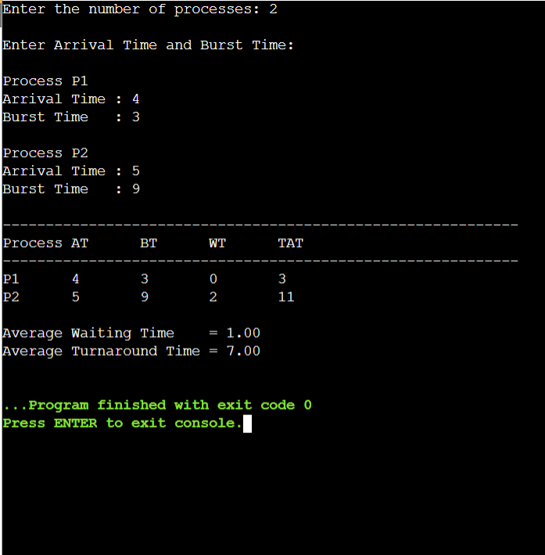

Program 8: Round Robin Scheduling
#include <stdio.h>
int main()
{
int n, i;
int burstTime[20], remainingTime[20];
int waitingTime[20] = {0};
int turnAroundTime[20];
int timeQuantum;
int time = 0;
int completed = 0;
float avgWT = 0, avgTAT = 0;
printf("Enter the number of processes: ");
scanf("%d", &n);
printf("\nEnter Burst Time for each process:\n");
for (i = 0; i < n; i++)
{
printf("P%d: ", i + 1);
scanf("%d", &burstTime[i]);
remainingTime[i] = burstTime[i];
}
printf("\nEnter Time Quantum: ");
scanf("%d", &timeQuantum);
while (completed < n)
{
int done = 1;
for (i = 0; i < n; i++)
{
if (remainingTime[i] > 0)
{
done = 0;
if (remainingTime[i] > timeQuantum)
{
time += timeQuantum;
remainingTime[i] -= timeQuantum;
}
else
{
time += remainingTime[i];
waitingTime[i] = time - burstTime[i];
remainingTime[i] = 0;
completed++;
}
}
}
if (done)
break;
}
printf("\n--------------------------------------------------------\n");
printf("Process\tBurst Time\tWaiting Time\tTurnaround Time\n");
printf("--------------------------------------------------------\n");
for (i = 0; i < n; i++)
{
turnAroundTime[i] = burstTime[i] + waitingTime[i];
avgWT += waitingTime[i];
avgTAT += turnAroundTime[i];
printf("P%d\t%d\t\t%d\t\t%d\n",
i + 1,
burstTime[i],
waitingTime[i],
turnAroundTime[i]);
}
avgWT /= n;
avgTAT /= n;
printf("\nAverage Waiting Time = %.2f", avgWT);
printf("\nAverage Turnaround Time = %.2f\n", avgTAT);

return 0;
}
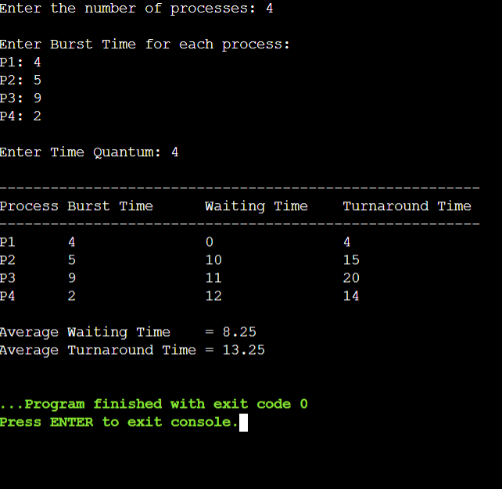

Program 9: Inter-Process Communication (IPC) using Shared Memory
#include <stdio.h>
#include <stdlib.h>
#include <sys/ipc.h>
#include <sys/shm.h>
#include <string.h>
int main()
{
key_t key;
int shmid;
char *sharedMemory;
/* Generate a unique key */
key = ftok("shmfile", 65);
/* Create shared memory */
shmid = shmget(key, 1024, 0666 | IPC_CREAT);
if (shmid == -1)
{
printf("Shared memory creation failed.\n");
return 1;
}
/* Attach shared memory */
sharedMemory = (char *)shmat(shmid, NULL, 0);
if (sharedMemory == (char *)-1)
{
printf("Unable to attach shared memory.\n");
return 1;
}
printf("Enter a message to store in shared memory:\n");
scanf(" %[^\n]", sharedMemory);
printf("\nData written into shared memory:\n%s\n", sharedMemory);
/* Detach shared memory */
shmdt(sharedMemory);
return 0;
}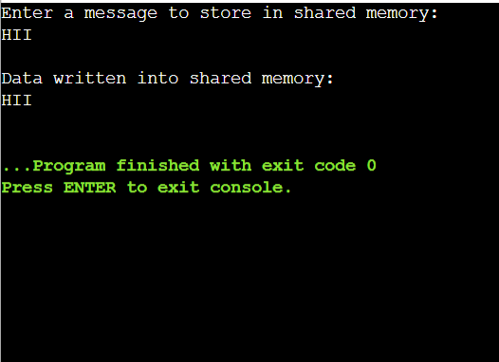

Program 10: Inter-Process Communication (IPC) using Message Queue
#include <stdio.h>
#include <stdlib.h>
#include <string.h>
#include <sys/ipc.h>
#include <sys/msg.h>
struct message
{
long messageType;
char messageText[100];
};
int main()
{
key_t key;
int messageID;
struct message msg;
/* Generate a unique key */
key = ftok("msgqueue", 65);
/* Create a message queue */
messageID = msgget(key, 0666 | IPC_CREAT);
if (messageID == -1)
{
printf("Failed to create message queue.\n");
return 1;
}
msg.messageType = 1;
printf("Enter a message: ");
scanf(" %[^\n]", msg.messageText);
/* Send message */
if (msgsnd(messageID, &msg, sizeof(msg.messageText), 0) == -1)
{
printf("Message sending failed.\n");
return 1;
}
printf("\nMessage sent successfully.\n");
/* Receive message */
if (msgrcv(messageID, &msg, sizeof(msg.messageText), 1, 0) == -1)
{
printf("Message receiving failed.\n");
return 1;
}
printf("Received Message: %s\n", msg.messageText);
/* Remove the message queue */
msgctl(messageID, IPC_RMID, NULL);
return 0;
}
